Stark sexual dimorphism in flowering responses to vernalization in a monoecious shrub

D.M. Buonaiuto^{1,2,3a}

¹Department of Plant Science and Landscape Architecture, University of Maryland. College Park MD, USA

² Department of Organismic and Evolutionary Biology, Harvard University, Cambridge, Massachusetts, USA

³Arnold Arboretum of Harvard University, Boston, Massachusetts, USA

ªcorresponding author: 617-823-0687; dbuona@umd.edu, ORCID:0000-0003-4022-2591

Many plants produce separate male and female flowers on the same individual. This reproductive strategy—-known as monoecy—is wide-spread and present in some of the most ecologically important taxa in the temperate zone including the oak (Fagaceae), maple (Sapindaceae) and birch (Betulaceae) families ¹. Both the male and female flowers of temperate monoecious species regulate their flowering using the same environmental cues; vernalization—exposure to cool (~0-5℃) temperatures in the winter, forcing—exposure to warm spring temperatures, and daylength ². There is emerging evidence that male and female flowers may respond differently to variation in these cues, but these differences are poorly characterized ^{3,4}. Through manipulating temperature and light cues in a controlled environment, I found that the male and female flowers of a widespread woodland shrub, sweetfern (Comptonia peregrina) had divergent response patterns to environmental variation. Most notably, virtually no male catkins opened after exposure to a thirty day vernalization period, while after sixty days of vernalization, almost all did, regardless of the forcing and photoperiod conditions to which they were also subjected. This stark finding has implications for plant reproduction in the context of anthropogenic climate change.

Climate change has already altered the timing and intensity of plant flowering in the past several decades, and shifts in forcing temperatures and vernalization exposure are expected to continue in decades to come ⁵. To better understand how these changes will affect pollination dynamics for monoecious species, I analyzed unpublished data from a 2021 experiment by Buonaiuto and Wolkovich ⁶, focusing on one monoecious species, Comptonia peregrina, that was included in the original study with sufficient observations of both female and male flowering for further analyses.

C. peregrina is a low growing, many-branched deciduous shrub native to eastern North America. Its elongate male catkins cluster at the tip of its branches while the female flowers develop in globose catkins that subtend the male inflorescences ⁷. Because of C. peregrina’s taxonomic position in the order Fageles, its reproductive structures are morphologically similar to oaks, beeches and birches, making it a useful species to investigate flowering patterns that may be relevant to other ecologically important taxa.

For this investigation, I used Bayesian regression models with a binomial response function to compare the likelihood of flowering between male and female flowers of C. peregrina under combinations of vernalization, forcing and photoperiod treatments (see Supporting Information: Methods).

Both male and female flowering likelihood was dependent on vernalization, but the effect was substantially stronger for male flowering, with the average likelihood of flowering increasing from 0.0 UI₈₉[0.0,0.01] to 0.93 UI₈₉[0.70 ,1.0] for male flowering, and from 0.30 UI₈₉[0.03, .74] to 0.60 UI₈₉[0.17, .95] for female flowering (Figure 1a). Changes in photoperiod length and forcing temperature had no measurable effects, though at higher vernalizations levels, longer photoperiods further enhanced male flowering likelihood. (Figure 1b, vernalization:photoperiod effect).

While sexual dimorphism in responses to environmental variation is commonly observed in a diversity of taxa ⁸, to my knowledge, this is the first study to investigate sexual dimorphism in vernalization responses specifically in monoecious plants. These results demonstrate that even on the same individual, sex phases can have strongly divergent responses to environmental variation. The differences between sex phases in the response to vernalization that I observed is consistent with findings from phenological studies that report higher environmental sensitivity, and more variability, in reproductive timing for male vs. female flowering phases ³.

Plants reportedly invest more heavily in female reproductive function under stressful conditions associated with climate change ⁹. It has even been observed that individuals switch from predominantly male flowered to female dominated flowering with increased environmental stress ¹⁰. My results, that male reproductive investment is terminated under low vernalization scenarios, is consistent with this finding, and demonstrates a mechanism that can shift sex ratios in a population under stress, even after sexual differentiation has occurred during the development phase.

The differences in vernalization treatment levels from this study are on par with projected changes in chilling accumulation due to climate change for the Northeastern United States⁵. The results of this analysis indicate that climate change may compromise male reproductive fitness more strongly than female reproductive fitness. Of course, with this study’s in-depth focus on one population of a single species, readers should be cautious extrapolating this pattern broadly, and more research is needed to understand both the individual dynamics of sexual dimorphism in flowering responses and their larger implication for population fitness. The stark sexual dimorphism in the flowering response to vernalization observed in this study highlights the importance of studying these effects more broadly to better predict and manage the effects of climate change on plant reproductive fitness.

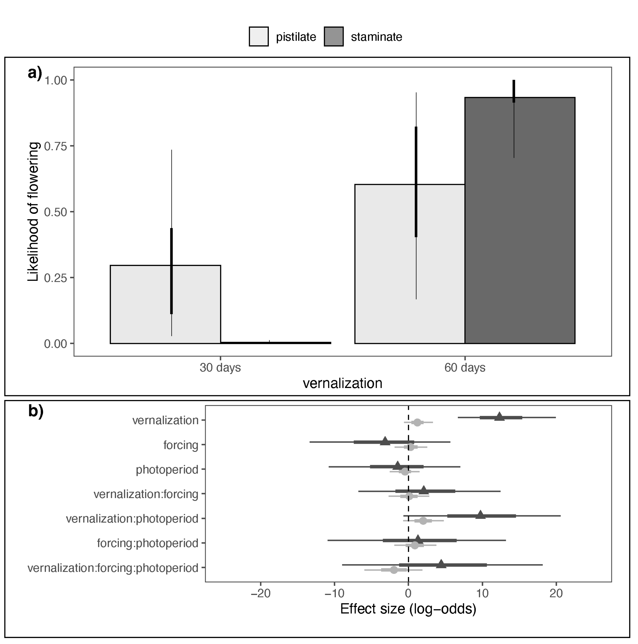
Figure 1: Effects of vernalization, forcing and photoperiod on the likelihood of flowering for male and female catkins of the monoecious shrub, Comptonia peregrina. Panel a) depicts the flowering likelihood in response to two levels of vernalization for male and female flowers. The color bars represent the mean estimated likelihood and the think and thin error bars represent the 50% and 89% uncertainty intervals, respectively. Panel b) depicts the estimated effect of vernalization, forcing temperature and photoperiod and their combined interactions on the likelihood of male and female flowering. The points represent the mean estimate and the thick and thin bars the 50% and 89% uncertainty intervals.

References:

1. Zhang, M., Hu, X., and He, F. (2024). Regional effects and local climate jointly shape the global distribution of sexual systems in woody flowering plants. Biogeosciences 21, 2133–2142. https://doi.org/10.5194/bg-21-2133-2024.
2. Forrest, J., and Miller-Rushing, A.J. (2010). Toward a synthetic understanding of the role of phenology in ecology and evolution. Philos. Trans. R. Soc. B Biol. Sci. 365, 3101–3112. https://doi.org/10.1098/rstb.2010.0145.
3. Buonaiuto, D.M. (2024). How Climate Change May Impact Plant Reproduction and Fitness by Altering the Temporal Separation of Male and Female Flowering. Glob. Change Biol. 30, e17533. https://doi.org/10.1111/gcb.17533.
4. Xie, Y., Thammavong, H.T., Berry, L.G., Huang, C.H., and Park, D.S. (2023). Sex-dependent phenological responses to climate vary across species’ ranges. Proc. Natl. Acad. Sci. 120, e2306723120. https://doi.org/10.1073/pnas.2306723120.
5. Wolfe, D.W., Ziska, L., Petzoldt, C., Seaman, A., Chase, L., and Hayhoe, K. (2008). Projected change in climate thresholds in the Northeastern U.S.: implications for crops, pests, livestock, and farmers. Mitig. Adapt. Strateg. Glob. Change 13, 555–575. https://doi.org/10.1007/s11027-007-9125-2.
6. Buonaiuto, D.M., and Wolkovich, E.M. (2021). Differences between flower and leaf phenological responses to environmental variation drive shifts in spring phenological sequences of temperate woody plants. J. Ecol. 109, 2922–2933. https://doi.org/10.1111/1365-2745.13708.
7. Barnes, B.V., Dick, C.W., and Gunn, M.E. (2016). Michgan Shrubs & Vines: A guide to species of the Great Lakes Region (University of Michigan Press).
8. Hangartner, S., Sgrò, C.M., Connallon, T., and Booksmythe, I. (2022). Sexual dimorphism in phenotypic plasticity and persistence under environmental change: An extension of theory and meta-analysis of current data. Ecol. Lett. 25, 1550–1565. https://doi.org/10.1111/ele.14005.
9. Petry, W.K., Soule, J.D., Iler, A.M., Chicas-Mosier, A., Inouye, D.W., Miller, T.E.X., and Mooney, K.A. (2016). Sex-specific responses to climate change in plants alter population sex ratio and performance. Science 353, 69–71. https://doi.org/10.1126/science.aaf2588.
10. Blake-Mahmud, J., and Struwe, L. (2019). Time for a change: patterns of sex expression, health and mortality in a sex-changing tree. Ann. Bot. 124, 367–377. https://doi.org/10.1093/aob/mcz037.

